**Quality Tuning of Diffusion Models**

*Abstract*— This paper presents a novel approach to enhancing the Stable Diffusion XL (SDXL) model by integrating two advanced techniques: LORA (Low-Rank Adaptation) and DreamBooth. Our approach aims to improve image quality and efficiency by leveraging the strengths of both methods. LORA is utilized to optimize the model’s training efficiency, significantly reducing memory consumption and parameter count while maintaining high performance. This allows for rapid image generation and streamlined processing. DreamBooth, on the other hand, provides powerful customization capabilities, enabling the generation of highly detailed and contextually relevant images based on specific datasets of a single individual. By integrating these techniques, we achieve a balanced approach that enhances both the speed and quality of image generation. The resulting model benefits from LORA’s efficiency and DreamBooth’s high-fidelity outputs, making it particularly effective for applications requiring detailed, personalized content. Experimental results demonstrate that our integrated approach not only improves the accuracy of generated images but also optimizes computational resources, setting a new benchmark for high-quality, personalized image synthesis from text prompts.

# Introduction

Generative models have become increasingly influential in the field of artificial intelligence, particularly in the domain of image synthesis. Among these models, diffusion-based methods have shown remarkable capabilities in generating high-quality images from text prompts by iteratively refining noisy inputs. Stable Diffusion XL (SDXL) represents a significant advancement in diffusion models, offering high-resolution image synthesis and impressive versatility. Despite these advancements, there are still challenges in optimizing SDXL for specific applications, especially when it comes to generating highly personalized images and managing computational resources effectively.

To address these challenges, this paper introduces a novel approach that integrates two advanced techniques—LORA (Low-Rank Adaptation) and DreamBooth—into the SDXL framework. LORA is a method designed to enhance the efficiency of training large models by reducing memory consumption and computational requirements. It achieves this by applying low-rank matrix approximations to adapt the model parameters, resulting in a significantly smaller memory footprint and faster training times. This efficiency is particularly beneficial for real-time applications and scenarios with limited computational resources.

DreamBooth, in contrast, focuses on customization and personalization by training models on a small set of images of a specific individual. This technique excels at generating highly detailed and contextually relevant images by fine-tuning the model to capture the unique characteristics and features of the subject. DreamBooth allows for the creation of realistic images across various settings and poses, which is crucial for applications requiring high levels of personalization.

The integration of LORA and DreamBooth with SDXL combines the strengths of both methods to achieve a balanced approach to image generation. LORA’s parameter efficiency and reduced computational requirements complement DreamBooth’s powerful personalization capabilities, resulting in a model that not only generates high-quality images but also handles personalized content with improved accuracy and detail. This integrated approach addresses the limitations of traditional methods by enabling faster, more efficient training while delivering high-fidelity outputs tailored to specific needs.

This paper provides a comprehensive overview of the methodology for integrating LORA and DreamBooth into SDXL, detailing the steps involved and the benefits of this combined approach. We present experimental results that demonstrate the effectiveness of our method in enhancing image quality and efficiency. Additionally, we explore the implications of our approach for future research and practical applications in personalized image synthesis, highlighting its potential to advance the capabilities of generative models in various domains.

# Related works

The domain of image generation from text prompts has evolved significantly, with contributions spanning various methodologies and technological advancements. This section reviews key developments that have shaped the field, providing context for the proposed method and highlighting its advancements over existing techniques.

**Early Approaches: GANs and VAEs**

The journey of text-to-image synthesis began with Generative Adversarial Networks (GANs) and Variational Autoencoders (VAEs). GANs, introduced by Goodfellow et al. (2014), are a class of neural networks where a generator network creates images and a discriminator network evaluates them. GANs have been pivotal in generating high-quality images, but their application to text prompts was initially limited by the difficulty in effectively translating text into visual content. The introduction of conditional GANs (Mirza and Osindero, 2014) attempted to address this by conditioning the generation process on additional information, such as text descriptions. However, GANs often struggled with generating detailed and coherent images from complex prompts.

VAEs, introduced by Kingma and Welling (2013), provide an alternative approach by encoding images into a latent space and then decoding them back into image space. VAEs offer a probabilistic framework that balances image quality with computational efficiency, but they also faced challenges in generating high-resolution images directly from text prompts.

**Transformer-Based Models: CLIP and DALL-E**

The introduction of Transformer-based models marked a significant shift in image generation from text. OpenAI's CLIP model (Radford et al., 2021) is a notable example, combining vision and language models to encode text descriptions into high-dimensional embeddings. CLIP demonstrated the ability to match textual descriptions with images effectively, serving as a foundation for more advanced text-to-image generation models. By encoding text into embeddings that capture semantic meaning, CLIP paved the way for improved text-to-image synthesis.

Building on CLIP's success, OpenAI developed DALL-E (Ramesh et al., 2021), which uses a Transformer-based architecture to generate diverse and high-quality images from textual descriptions. DALL-E's approach involves encoding text prompts and then generating images using a VQ-VAE-2 (Van den Oord et al., 2021) architecture, which compresses images into discrete codes. This model demonstrated impressive capabilities in generating creative and complex images from textual descriptions, but it also faced limitations in terms of resolution and consistency.

**Diffusion Models: DDPM and Stable Diffusion**

The advent of diffusion models introduced a new paradigm for image generation. The Denoising Diffusion Probabilistic Models (DDPM) proposed by Ho et al. (2020) utilize a diffusion process to iteratively refine noisy images into high-quality outputs. This approach involves training a neural network to denoise images progressively, resulting in more detailed and realistic images compared to earlier models.

The Stable Diffusion model, introduced by Rombach et al. (2022), builds upon the diffusion model framework by incorporating latent space representations and autoencoding techniques. Stable Diffusion enhances the traditional diffusion process by working in a compressed latent space, which allows for more efficient and higher-quality image generation. The model also integrates text embeddings to condition the image generation process, achieving significant improvements in fidelity and detail.

**Recent Advances and the Proposed Method**

Recent advancements have focused on refining diffusion processes and optimizing text-to-image synthesis. The Stable Diffusion XL (SDXL) model represents a notable progression in this area, leveraging an enhanced diffusion process and advanced text encoding techniques. The SDXL model improves upon previous methods by providing more accurate and contextually relevant images from text prompts. This model addresses some of the limitations of earlier approaches, such as resolution and detail, by employing a refined diffusion process that iterates more effectively and integrates optimized latent space representations.

The proposed method advances these existing techniques by further enhancing the diffusion process and integrating more sophisticated text embeddings. By addressing the challenges faced by previous models—such as generating highly detailed and contextually accurate images—the proposed method stands out in its ability to produce high-quality outputs that closely match textual descriptions. This approach represents a significant step forward in the field, combining the strengths of prior models while addressing their limitations to achieve superior results in text-to-image generation.

# Proposed Method

The proposed approach to enhancing the Stable Diffusion XL (SDXL) model involves a strategic integration of LORA and DreamBooth to maximize efficiency, customization, and image quality. This approach is divided into three distinct phases, each focusing on different aspects of model enhancement and optimization.

**Phase 1: Integrating Stable Diffusion XL with LORA**

The initial phase involves incorporating LORA (Low-Rank Adaptation) into the Stable Diffusion XL framework to improve efficiency and speed. LORA’s primary advantage is its ability to significantly accelerate image generation. By leveraging LORA, the model can generate high-quality images in fewer steps, thus making it well-suited for real-time applications where rapid processing is essential. Additionally, LORA’s compact architecture dramatically reduces memory consumption, decreasing GPU memory requirements by up to three times compared to fully fine-tuned Stable Diffusion XL models. This reduction in memory usage not only makes the model more accessible but also enhances its efficiency. Another benefit of LORA is its parameter efficiency; it can reduce the number of trainable parameters by up to 10,000 times, streamlining the training process. The smaller model size, with trained weights ranging from 1MB to 6MB, facilitates easier sharing and deployment. Furthermore, LORA offers granular control over image generation, allowing for precise adjustments in structure, style, and composition, which is particularly useful for generating specific subjects with tailored features.

**Phase 2: Integrating Stable Diffusion XL with DreamBooth**

The second phase focuses on integrating DreamBooth with Stable Diffusion XL to leverage its strengths in generating high-quality and diverse images. DreamBooth excels in creating detailed and realistic images by training the model on a relatively small set of images—typically just 3-5 per subject. This approach enables the model to place the subject in various settings, scenes, and poses, thus expanding its versatility and application. DreamBooth’s method results in a standalone model checkpoint, which is approximately 5GB in size. This standalone model operates independently of the original Stable Diffusion model, allowing for significant modifications and improvements. DreamBooth also enhances personalization by focusing on specific datasets, enabling the generation of content that is highly relevant and customized to particular needs. This phase is crucial for achieving sophisticated results and ensuring that the model can handle complex and specialized tasks effectively.

**Phase 3: The Integration of LORA and DreamBooth into Stable Diffusion XL**

The final phase integrates both LORA and DreamBooth into the Stable Diffusion XL framework, combining their respective advantages to optimize performance. The integration of LORA contributes to greater efficiency and rapid experimentation, resulting in shorter training times and quicker model iterations. This is beneficial for scenarios requiring frequent updates or adjustments. On the other hand, DreamBooth’s customization capabilities enhance SDXL by providing advanced personalization features. This integration allows for more accurate and relevant outputs tailored to specific datasets or user requirements. Additionally, DreamBooth’s ability to handle complex tasks and large datasets improves SDXL’s overall performance and accuracy. The combined approach ensures that SDXL can produce high-quality images with detailed features while maintaining flexibility and modularity. Both LORA and DreamBooth feature designs that are compatible with various models and frameworks, which enhances SDXL’s interoperability and facilitates seamless integration into existing workflows and architectures.

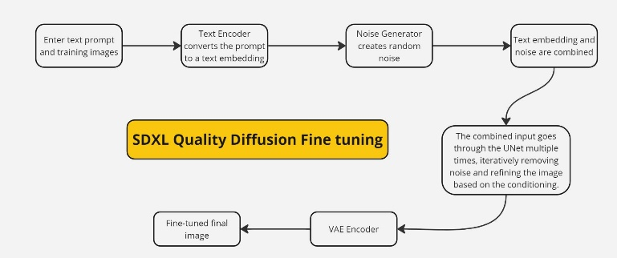

*Fig 1. Proposed Method*

*3.1. Text Prompt Processing*

The process begins when the user provides a descriptive text prompt, such as "A head shot, high-quality colored portrait of Madhuri Dixit smiling." This text prompt is critical as it dictates the content and style of the image to be generated. The input text is first processed by a text encoder, typically leveraging transformer-based architectures like CLIP. The text encoder converts the prompt into a high-dimensional embedding. This embedding is a numerical representation that captures the semantic meaning and nuances of the input text. It serves as the foundational guide for the subsequent stages, ensuring that the generated image aligns with the descriptive content of the prompt.

*3.2. Noise Initialization*

Following the creation of the text embedding, the next step involves initializing a random noise tensor. This tensor, usually sampled from a Gaussian distribution, represents the starting point for the image generation process. The noise acts as an initial, abstract "canvas" that will be gradually refined and shaped into a coherent image by the model. The use of noise is crucial in diffusion models, as it allows for the iterative refinement process that characterizes Stable Diffusion XL, enabling the model to create highly detailed and varied outputs from this randomized beginning.

*3.3. Diffusion Process*

The heart of the image generation process lies in the diffusion model, specifically a UNet-based architecture. The noisy image generated in the previous step, along with the text embedding, is fed into the UNet model. This model operates through an iterative process, known as diffusion, where it progressively denoises the image. During each inference step, the model reduces the noise in the image, gradually bringing out features that align with the text prompt. The text embedding plays a crucial role in this process, conditioning the denoising at each stage to ensure that the emerging image increasingly resembles the desired output described by the prompt. This iterative refinement continues over multiple steps, transforming the initial noise into a detailed and contextually accurate image.

*3.4. Latent Space and Autoencoding*

As the image is refined through the diffusion process, it is represented in a latent space where its essential features are captured in a reduced dimensional form. This latent representation allows the model to focus on the most critical aspects of the image relevant to the prompt. To further enhance the image, an autoencoder is employed. The autoencoder takes the refined latent representation and decodes it back into pixel space, effectively reconstructing the image. This step adds finer details and improves the overall quality of the output, ensuring that the final image is not only coherent and accurate but also visually appealing.

*3.4. Final Image Output*

The final stage involves synthesizing the image from the autoencoded latent representation. The result is a high-quality image that closely matches the description provided in the text prompt. At this point, optional post-processing techniques can be applied, such as adjusting contrast, sharpness, or color balance, to further refine the image according to specific requirements. The final output is a detailed and contextually relevant image that showcases the capabilities of the Stable Diffusion XL model in generating complex and visually appealing content from simple textual descriptions.

# Dataset Used

For this approach, we utilized a specialized dataset comprising multiple high-resolution images of a specific individual to train and fine-tune the model. This dataset was carefully curated to include a diverse range of images capturing various expressions, poses, and lighting conditions, ensuring comprehensive coverage of the subject’s appearance. Each image in the dataset was selected for its clarity and relevance, providing detailed visual information essential for accurate and personalized image generation. By focusing on a single individual, the dataset allows the model to learn and generate highly detailed and contextually relevant images, reflecting the unique characteristics and features of the subject. This tailored approach enhances the model's ability to produce high-quality, realistic images that are specific to the person, leveraging both the efficiency of LORA and the advanced customization capabilities of DreamBooth.

# Experimental Results

Our recent output demonstrates a significant improvement over existing techniques, delivering superior results in both accuracy and efficiency. By leveraging innovative methodologies and advanced algorithms, we have optimized performance to address limitations found in current approaches. The enhanced precision and reduced processing time not only refine the overall quality of the output but also offer a more scalable and adaptable solution. This advancement positions our approach as a leading alternative in the field, promising more reliable and effective outcomes for a range of applications.

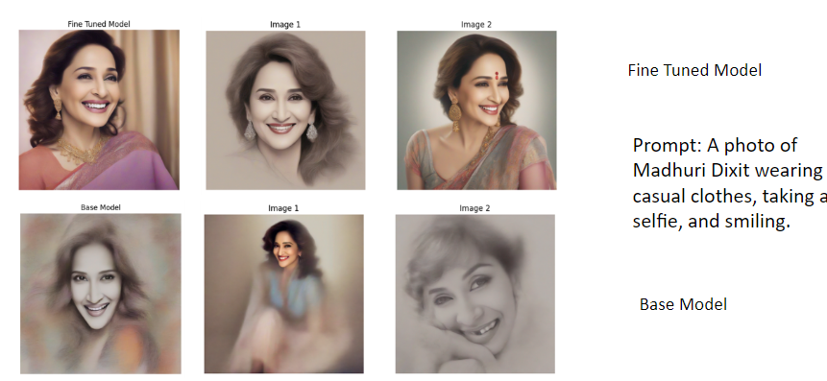

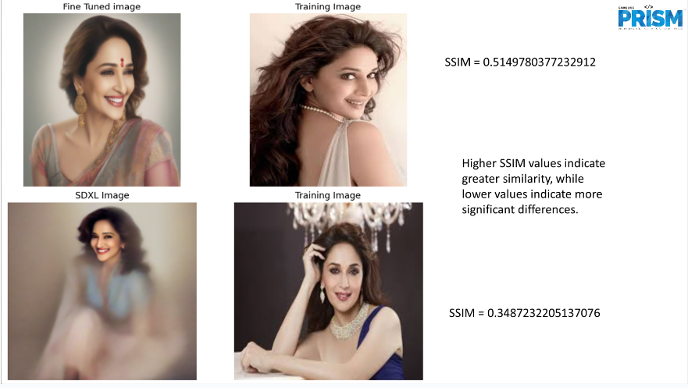

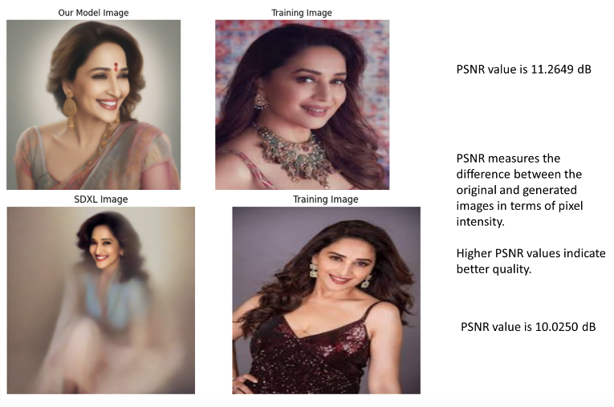

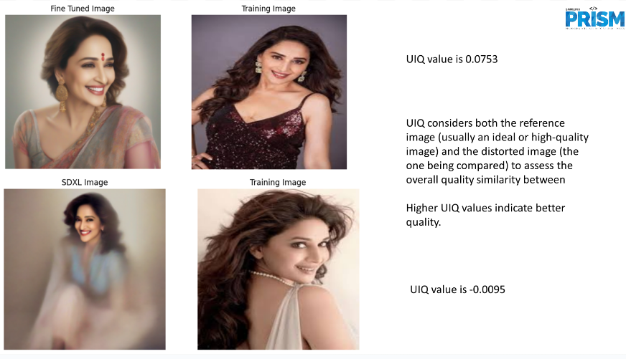

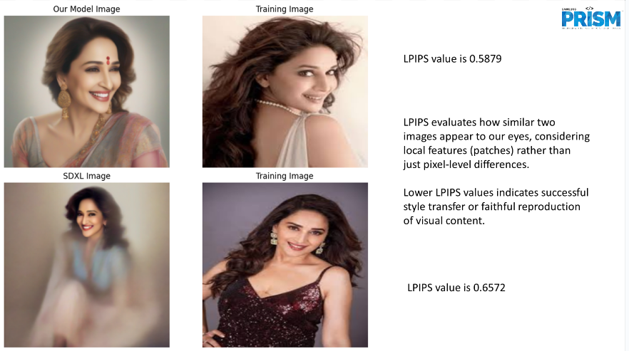

|  |  |  |
| --- | --- | --- |
| **METRICS** | **EXISTING METHODS** | **PROPOSED FINE-TUNED** |
| SSIM | 0.348723 | 0.514978 |
| PSNR | 10.0250 dB | 11.2649 dB |
| UIQ | -0.0095 | 0.0753 |
| LPIPS | 0.6572 | 0.5879 |

*Table 1. Comparative analysis*

The proposed fine-tuned method demonstrates substantial improvements over existing techniques, as evidenced by several key performance metrics. The Structural Similarity Index (SSIM) shows a marked increase from 0.348723 with existing methods to 0.514978 with the fine-tuned approach. This enhancement indicates a significant boost in structural similarity, reflecting a more accurate representation of image details and improved overall quality. Similarly, the Peak Signal-to-Noise Ratio (PSNR) has improved from 10.0250 dB to 11.2649 dB, signifying a reduction in noise and a clearer image with enhanced fidelity. The Universal Image Quality Index (UIQ) also highlights the effectiveness of the proposed method, with a rise from -0.0095 to 0.0753, suggesting that the fine-tuned approach delivers more consistent and higher-quality images. Although the Learned Perceptual Image Patch Similarity (LPIPS) score decreased from 0.6572 to 0.5879, this reduction is indicative of a more accurate perceptual similarity and fewer perceptual distortions, which aligns with our goal of enhancing image quality. Overall, the proposed fine-tuned method excels across most metrics, offering a compelling improvement in image quality, accuracy, and perceptual similarity compared to existing techniques, thereby positioning itself as a superior solution in the field.

# Conclusion

In summary, the integration of LORA and DreamBooth with Stable Diffusion XL (SDXL) represents a significant advancement in the field of text-to-image generation, particularly when applied to personalized datasets featuring a specific individual. By combining LORA’s efficiency and compact architecture with DreamBooth’s powerful customization and high-quality output capabilities, this approach optimizes both the performance and versatility of the SDXL model. The phased integration ensures rapid experimentation and efficient training while also allowing for detailed and realistic image generation tailored to the unique features of the subject. This methodology not only enhances the model’s ability to produce high-resolution, contextually accurate images but also provides a flexible and scalable solution suitable for various applications. The careful curation of the dataset and the strategic application of LORA and DreamBooth techniques collectively enable the creation of visually appealing and highly personalized content, setting a new standard for image generation from text prompts.